**Skyjet Case (u0872493)**

Cost of Overage = Co = 114

Cost of Underage = Cu = 174 - 114 = 60

Critical Ratio = Cu/Cu+Co = 60/60+114 = 0.345

We will use z = -0.4 derived from the z table on the basis of critical ratio of 0.345 (Here, z indicates the number of standard deviations that *Q* lies away from the mean

). Therefore, the amount of seats that should be protected must be the smallest integer closest to z * std. deviation + mean.

**Level 1**

I used all 365 days worth of data and calculated one mean and one standard deviation. Thus derived at one booking limit to cover all days of the year.

|  |  |
| --- | --- |
| N | 365 |
| Mean | 76 |
| Standard Deviation | 31.63 |

Protection Level = z * std. deviation + Mean = -0.4 * 31.63 + 76 = 63.34 = 63 (as per the reason stated above) for all the 365 days

Booking Limit = 146 - 63 = 83 for all the 365 days

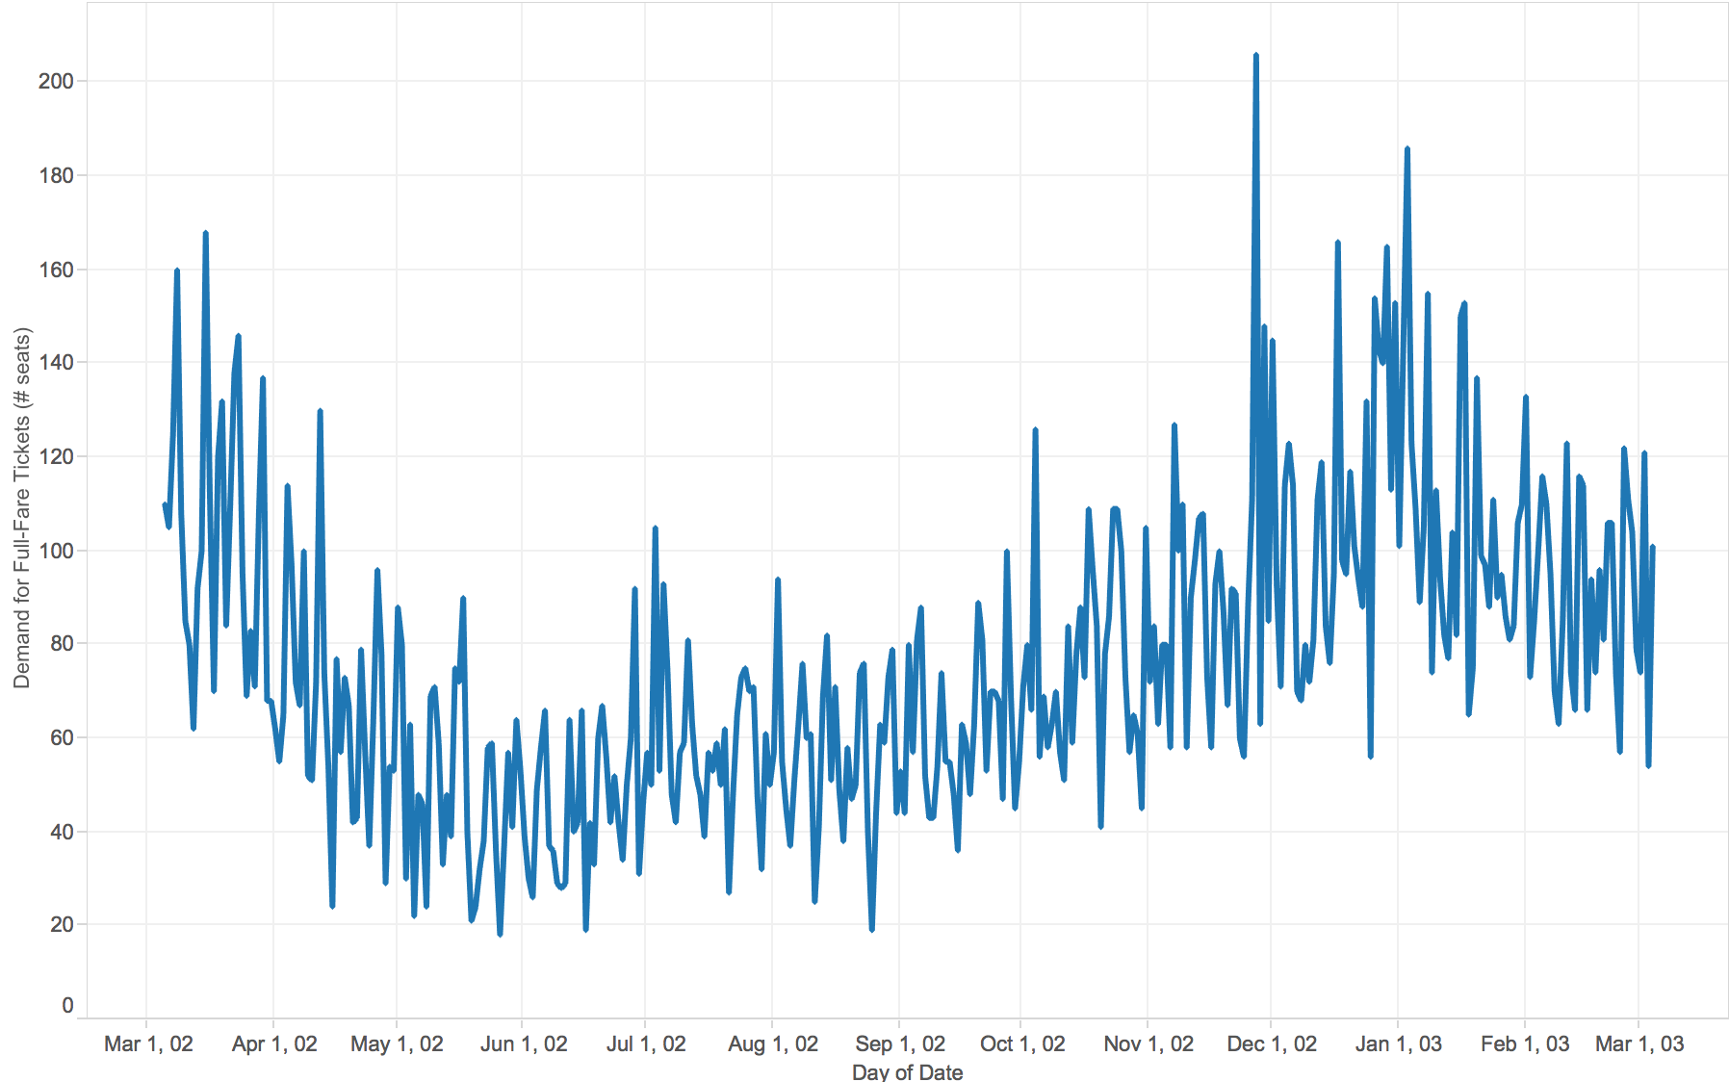

**Level 2**

I divided the data into 7 different data sets, one for each day of the week, finding 7 different means and 7 different standard deviations. After calculating mean and standard deviation of each data set, I got seven recommended booking limits to cover the 7 days of the week.

**Sunday**

|  |  |
| --- | --- |
| N | 52 |
| Mean | 60 |
| SD | 30.91 |

Protection Level = z * std. deviation + Mean = -0.4 * 30.91 + 60 = 47.63 = 47 (as per the reason stated above) for all the Sundays in that year

Booking Limit = 146 - 47 = 99 for all the Sundays in that year

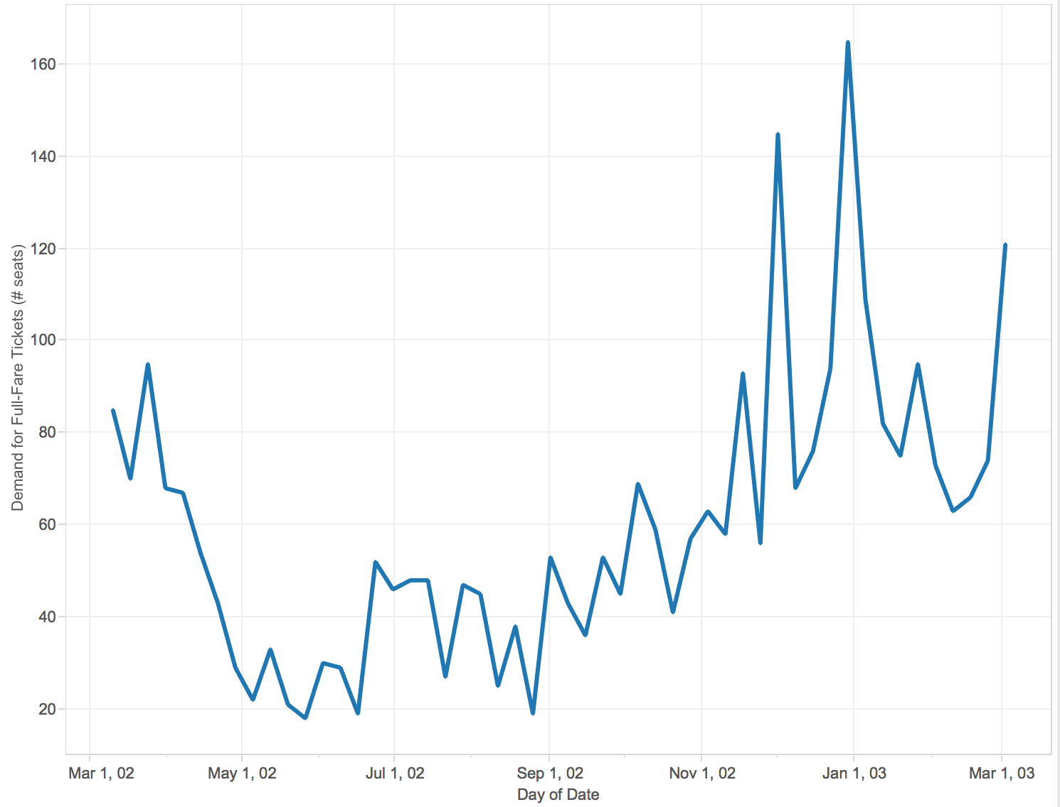

**Monday**

|  |  |
| --- | --- |
| N | 52 |
| Mean | 66 |
| SD | 26.16 |

Protection Level = z * std. deviation + Mean = -0.4 * 26.16 + 66 = 55.53 = 55(as per the reason stated above) for all the Mondays in that year

Booking Limit = 146 - 55 = 91 for all the Mondays in that year

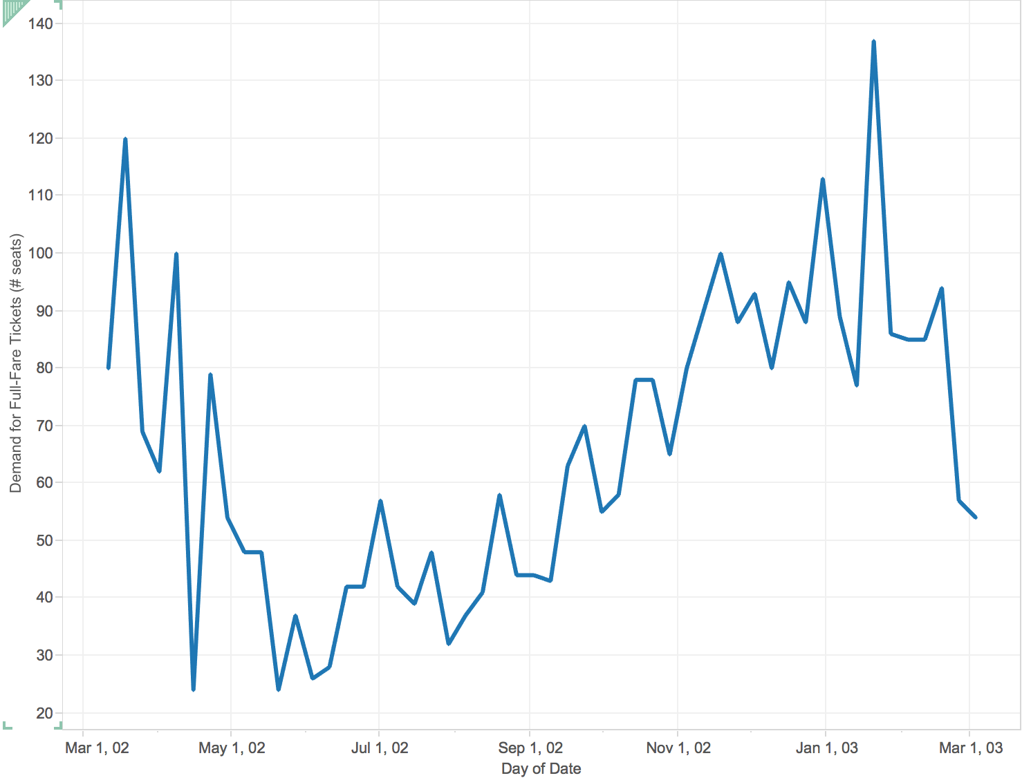

**Tuesday**

|  |  |
| --- | --- |
| N | 53 |
| Mean | 76 |
| SD | 30.77 |

Protection Level = z * std. deviation + Mean = -0.4 * 30.77 + 76 = 63.69 = 63 (as per the reason stated above) for all the Tuesdays in that year

Booking Limit = 146 - 63 = 83 for all the Tuesdays in that year

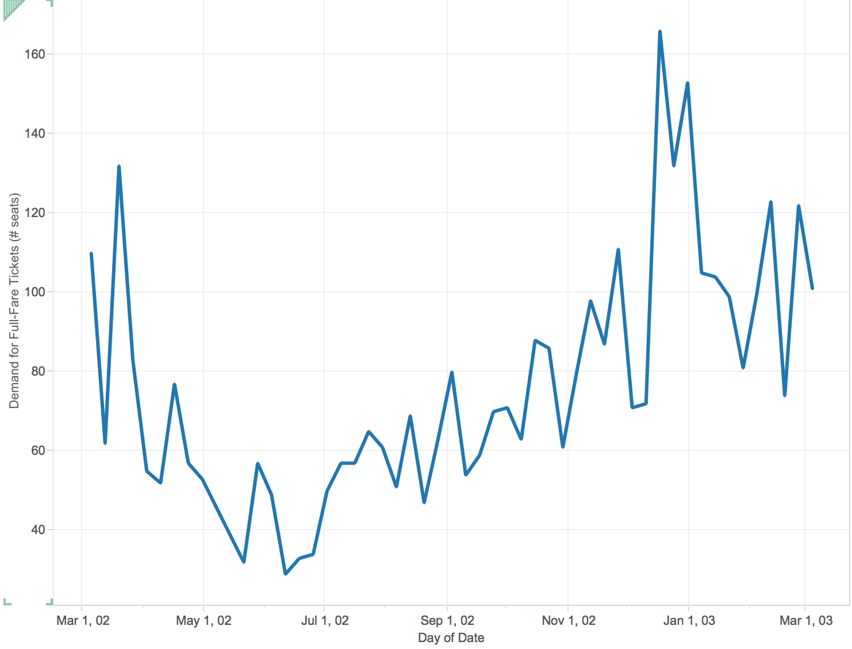

**Wednesday**

|  |  |
| --- | --- |
| N | 52 |
| Mean | 77 |
| SD | 30.94 |

Protection Level = z * std. deviation + Mean = -0.4 * 30.94 + 77 = 64.62 = 64 (as per the reason stated above) for all the Wednesdays in that year

Booking Limit = 146 - 64 = 82 for all the Wednesdays in that year

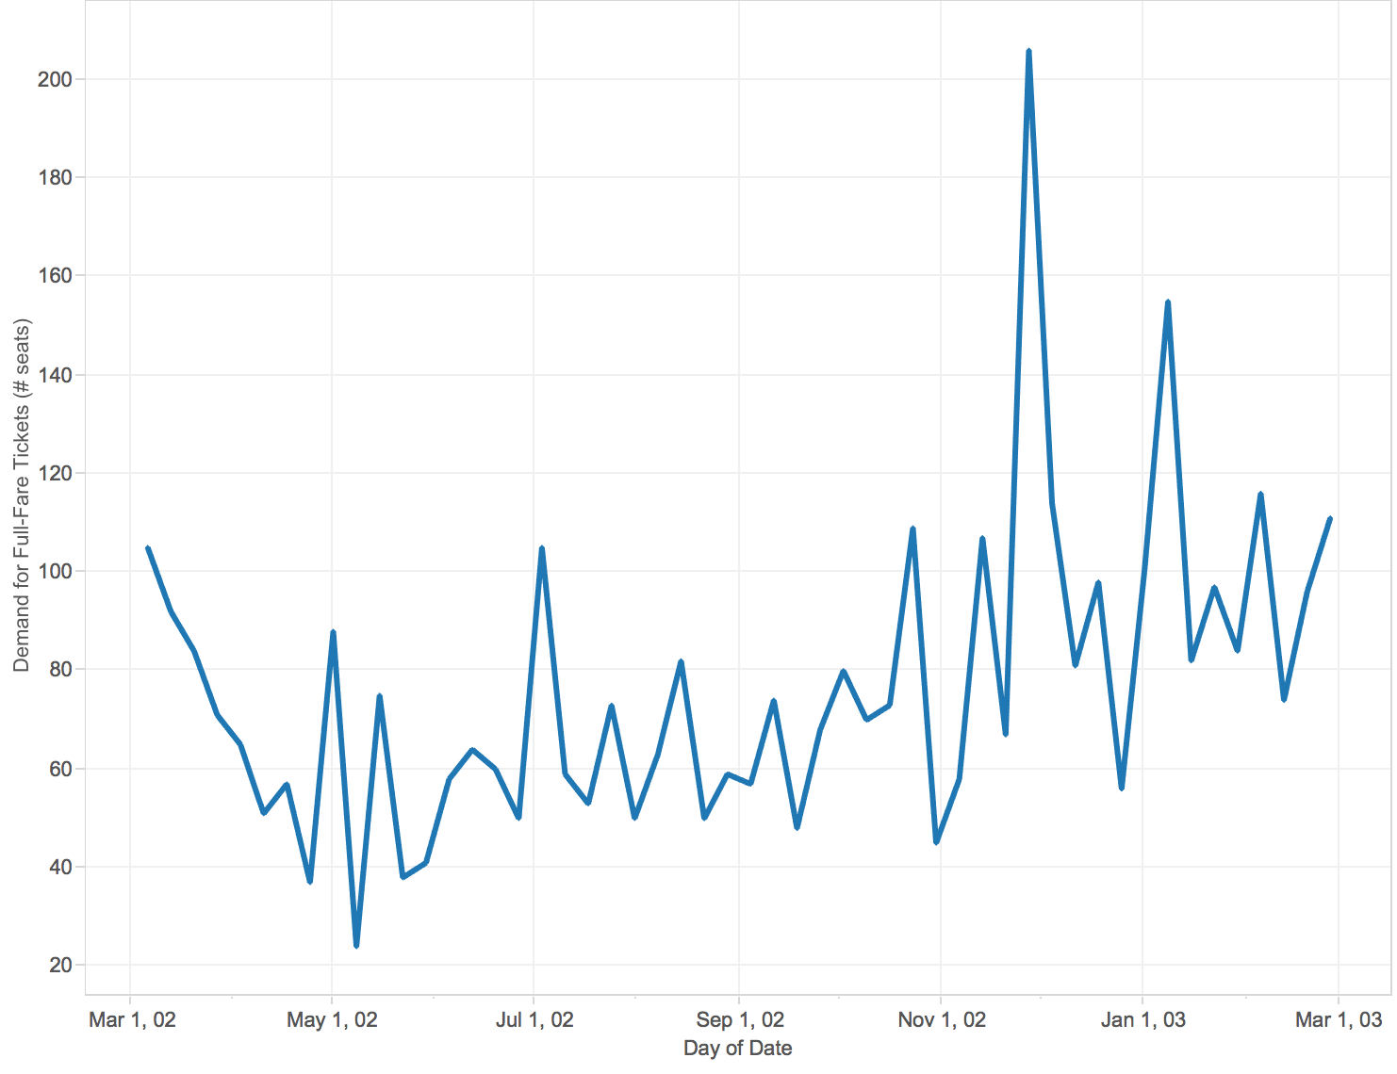

**Thursday**

|  |  |
| --- | --- |
| N | 52 |
| Mean | 85 |
| SD | 27.52 |

Protection Level = z * std. deviation + Mean = -0.4 * 27.52 + 85 = 73.99 = 73 (as per the reason stated above) for all the Thursdays in that year

Booking Limit = 146 - 73 = 73 for all the Thursdays in that year

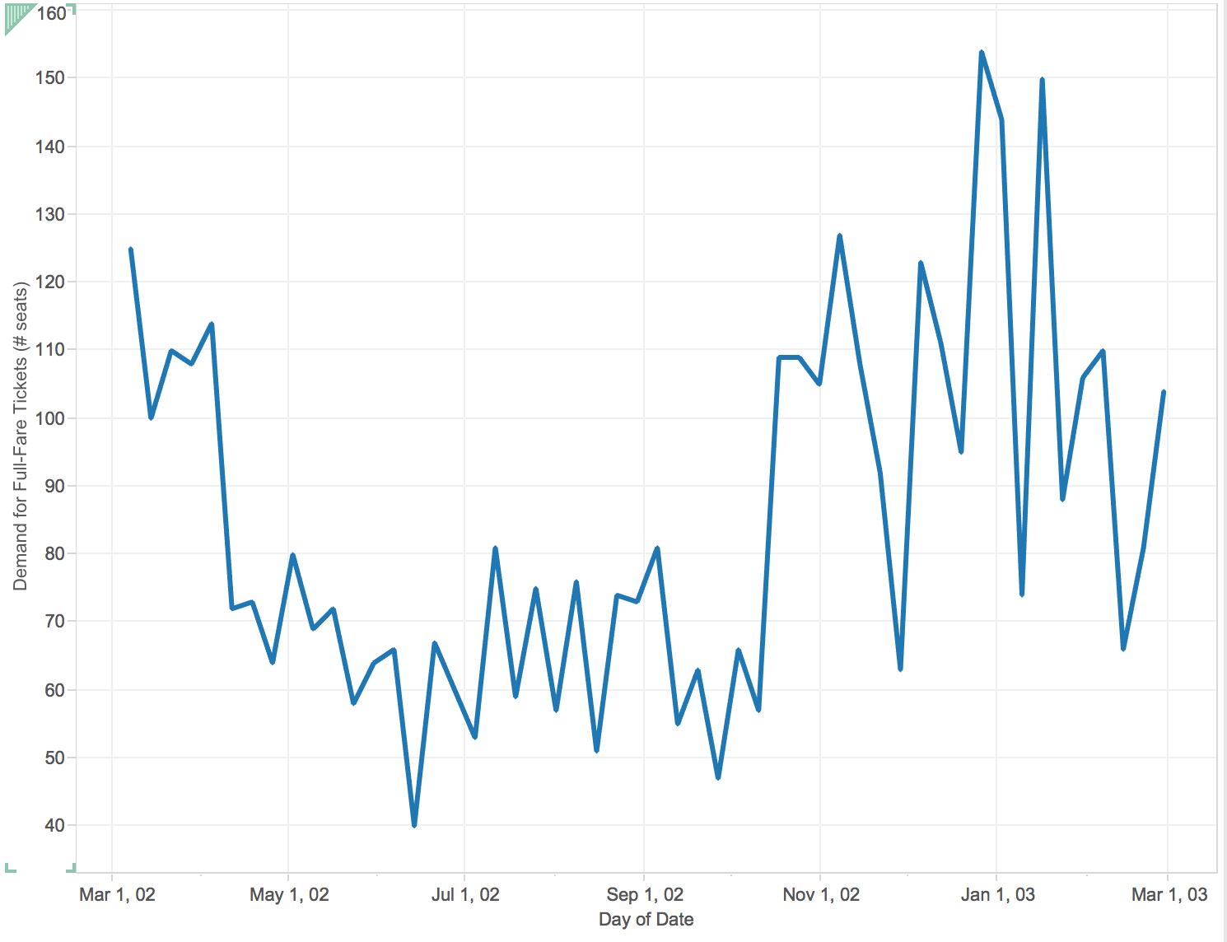

**Friday**

|  |  |
| --- | --- |
| N | 52 |
| Mean | 95 |
| SD | 34.97 |

Protection Level = z * std. deviation + Mean = -0.4 * 34.97 + 95 = 81.012 = 81 (as per the reason stated above) for all the Fridays in that year

Booking Limit = 146 - 81 = 65 for all the Fridays in that year

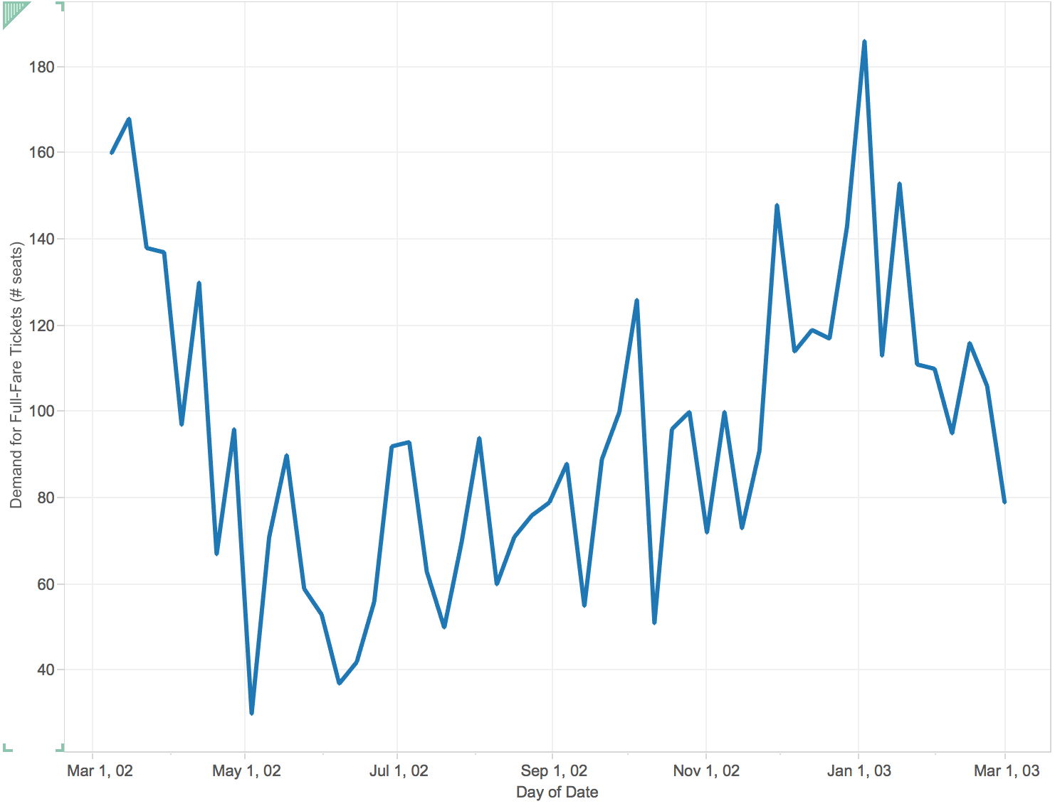

**Saturday**

|  |  |
| --- | --- |
| N | 52 |
| Mean | 74 |
| SD | 27.81 |

Protection Level = z * std. deviation + Mean = -0.4 * 27.81 + 74 = 62.87 = 62 (as per the reason stated above) for all the Saturdays in that year

Booking Limit = 146 - 62 = 84 for all the Saturdays in that year

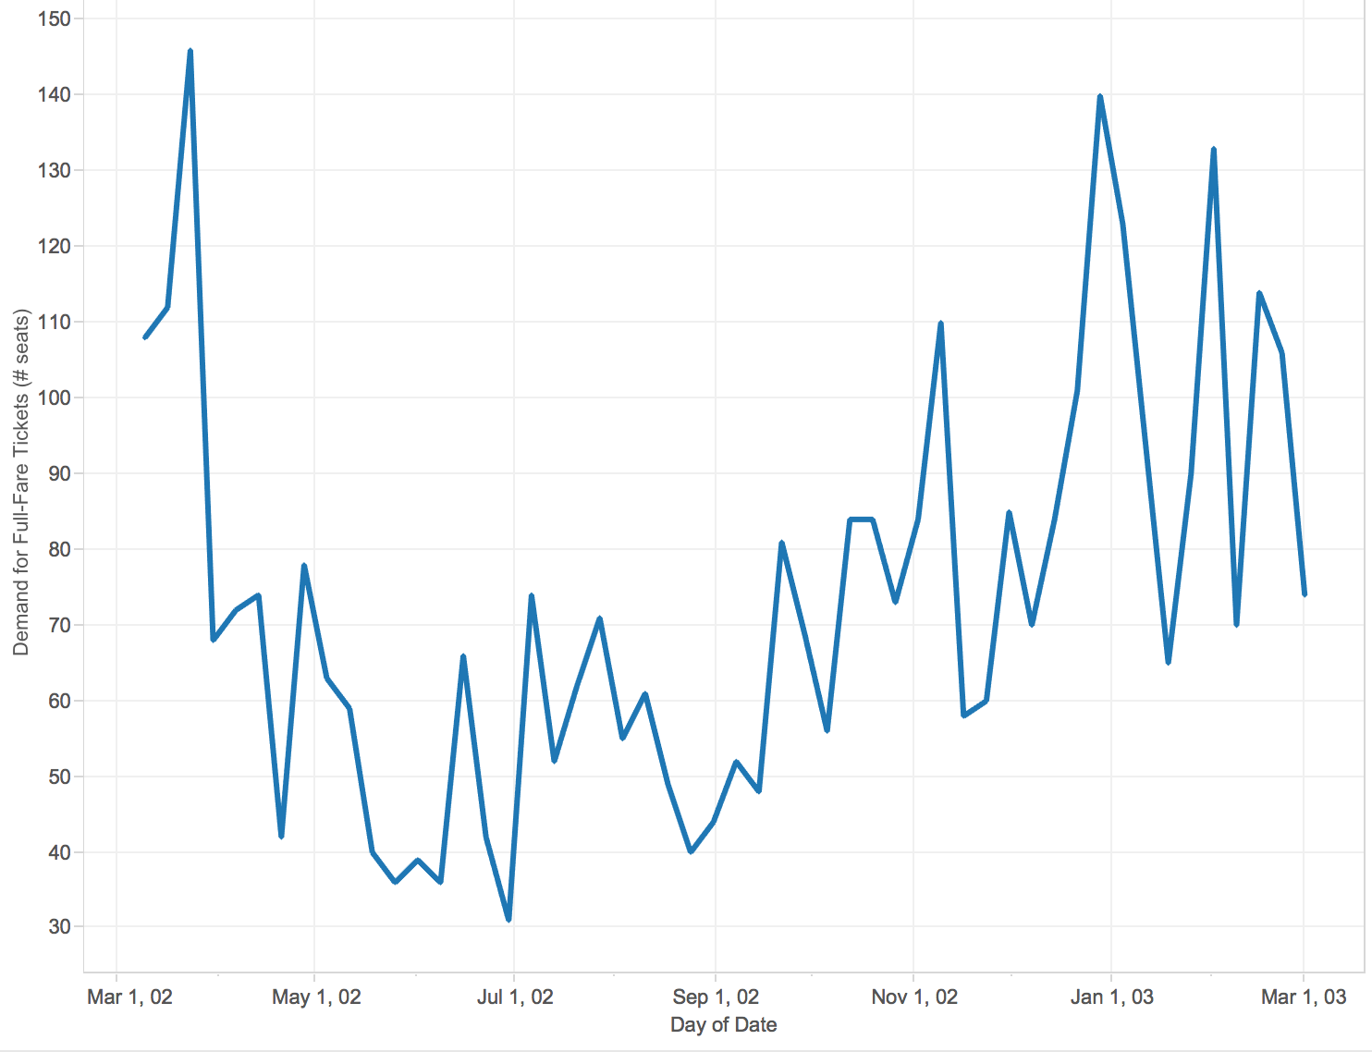

**Level 3**

Used the data as 1 data set but marked zero-one indicator variables to identify the day of the week, and ran one multiple linear regression to determine the regression intercept and coefficients associated with each day of the week. I got seven recommended booking limits to cover the 7 days of the week.

**Day of the Week** - Using the Linest() function as explained in the video, I got the following values.

|  |  |  |  |  |  |  |  |
| --- | --- | --- | --- | --- | --- | --- | --- |
| **Mean** | 65.88 | 76.06 | 76.56 | 85.17 | 94.81 | 73.62 | 59.81 |
|  | 13.80769231 | 35 | 25.36538462 | 16.75 | 16.24891147 | 6.076923077 | 59.80769231 |
|  | 5.882432791 | 5.882432791 | 5.882432791 | 5.882432791 | 5.854619714 | 5.882432791 | 4.159508116 |
|  | 0.115445335 | 29.99 | #N/A | #N/A | #N/A | #N/A | #N/A |
|  | 7.787238689 | 358 | #N/A | #N/A | #N/A | #N/A | #N/A |
|  | 42036.06286 | 322084.8687 | #N/A | #N/A | #N/A | #N/A | #N/A |
|  | Monday | Tuesday | Wednesday | Thursday | Friday | Saturday | Sunday |

**Standard Deviation** = 29.99

**Tuesday (March 18th):**

Protection Level = z * std. deviation + Mean = -0.4 * 29.99 + 76.06 = 64.06 = 64 (as per the reason stated above)

Booking Limit = 146 - 64 = 82

**Wednesday (March 19th):**

Protection Level = z * std. deviation + Mean = -0.4 * 29.99 + 76.56 = 64.56 = 64 (as per the reason stated above)

Booking Limit = 146 - 64 = 82

**Thursday (March 20th):**

Protection Level = z * std. deviation + Mean = -0.4 * 29.99 + 85.17 = 73.174 = 73 (as per the reason stated above)

Booking Limit = 146 - 73 = 73

**Friday (March 21st):**

Protection Level = z * std. deviation + Mean = -0.4 * 29.99 + 94.81 = 82.81 = 82 (as per the reason stated above)

Booking Limit = 146 - 82 = 64

**Saturday (March 22nd):**

Protection Level = z * std. deviation + Mean = -0.4 * 29.99 + 73.62 = 61.62 = 61 (as per the reason stated above)

Booking Limit = 146 - 61 = 85

**Sunday (March 23rd):**

Protection Level = z * std. deviation + Mean = -0.4 * 29.99 + 59.81 = 47.81 = 47 (as per the reason stated above)

Booking Limit = 146 - 47 = 99

**Monday (March 24th):**

Protection Level = z * std. deviation + Mean = -0.4 * 29.99 + 65.88 = 53.88 = 53 (as per the reason stated above)

Booking Limit = 146 - 73 = 93

**Seasonality**

I have assumed that there are 3 seasons in the year and their duration is as follows:

**Winter** - December, January, February, March

**Spring** - April, May, June, July

**Summer** - August, September, October, November

Using the linest function as explained in the video, I got the following values.

|  |  |  |  |
| --- | --- | --- | --- |
| **Mean** | 102.02 | 55.05 | 71.09 |
|  | -16.04918033 | 30.92643273 | 71.09836066 |
|  | 3.196940123 | 3.203538561 | 2.26057804 |
|  | 0.380185453 | 24.97 | #N/A |
|  | 111.0228331 | 362 | #N/A |
|  | 138433.4813 | 225687.4502 | #N/A |
|  | Winter | Spring | Summer |

**Standard Deviation** - 24.97

**Winter:**

Protection Level = z * std. deviation + Mean = -0.4 * 24.97 + 102.02 = 92.03 = 92 (as per the reason stated above)

Booking Limit = 146 - 92 = 54

**Spring:**

Protection Level = z * std. deviation + Mean = -0.4 * 24.97 + 55.05 = 45.06 = 45 (as per the reason stated above)

Booking Limit = 146 - 45 = 101

**Summer:**

Protection Level = z * std. deviation + Mean = -0.4 * 24.97 + 71.09 = 61.10 = 61 (as per the reason stated above)

Booking Limit = 146 - 61 = 85

**Level 4**

Considering both the day of the week and the seasonality of the year. As per my assumption above about the seasons, March 18 - 24 falls in winter. Therefore the mean values would be (using the linest function as shown in the video):

|  |  |  |  |  |  |  |  |
| --- | --- | --- | --- | --- | --- | --- | --- |
| **Mean** | 88.35 | 105 | 95.12 | 108.76 | 127.35 | 99.88 | 90.22 |
|  | Winter-Mon | Winter-Tue | Winter-Wed | Winter-Thurs | Winter-Fri | Winter-Sat | Winter-Sun |

**Standard deviation** - 22.90

**March 18th (Tuesday):**

Protection Level = z * std. deviation + Mean = -0.4 * 22.90 + 88.35 = 79.19 = 79 (as per the reason stated above)

Booking Limit = 146 - 79 = 67

**March 19th (Wednesday):**

Protection Level = z * std. deviation + Mean = -0.4 * 22.90 + 105 = 95.84 = 95 (as per the reason stated above)

Booking Limit = 146 - 95 = 51

**March 20th (Thursday):**

Protection Level = z * std. deviation + Mean = -0.4 * 22.90 + 95.12 = 85.96= 85 (as per the reason stated above)

Booking Limit = 146 - 85 = 61

**March 21st (Friday):**

Protection Level = z * std. deviation + Mean = -0.4 * 22.90 + 108.76 = 99.6 = 99 (as per the reason stated above)

Booking Limit = 146 - 99 = 47

**March 22nd (Saturday):**

Protection Level = z * std. deviation + Mean = -0.4 * 22.90 + 127.35 = 118.19 = 118 (as per the reason stated above)

Booking Limit = 146 - 118 = 28

**March 23rd (Sunday):**

Protection Level = z * std. deviation + Mean = -0.4 * 22.90 + 99.88 = 90.72 = 90 (as per the reason stated above)

Booking Limit = 146 - 90 = 56

**March 24th (Monday):**

Protection Level = z * std. deviation + Mean = -0.4 * 22.90 + 90.22 = 81.02 = 81 (as per the reason stated above)

Booking Limit = 146 - 81 = 65

Attached is the workbook where I have created my data.

